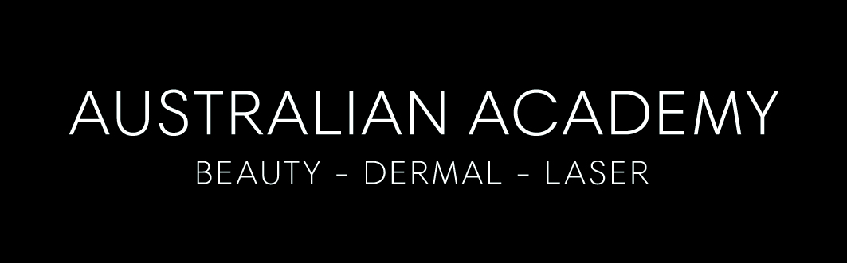

To all our valued clients,

At the Australian Academy of Beauty Dermal and Laser the health of our clients and students and staff is our number one priority.

We would like to reassure you, we are taking the Corona Virus very seriously and will continue to do so with minimal interruptions to our clinic services whilst providing our students staff and clients with the highest of care.

Following and keeping in line with the WHO (World Health Organisation) recommendations on preventative measures to protect against exposure to Viruses and the current Corona Virus we have implemented the following:

Client responsibilities
- If you have travelled overseas in the past 4 weeks, please phone the relevant academy and we will change your appointment to another time. No client will be permitted until the 15 day incubation period is over.

- If you feeling unwell in any way, including normal colds, chest infections etc, please phone the relevant academy and we will change your appointment to another time.

- We ask you to not attend unless completely well.

- If you have been in contact with anyone with or suspected corona virus, please obtain a medical clearance from you Doctor before attending and after the compulsory incubation period.

- Please use hand sanitiser prior to all appointments and after your appointment

Academy responsibilities

- No students or staff member is allowed to attend college with any colds or flu symptoms.

- No students or staff member who have recently been overseas is allowed to return to class until the compulsive incubation period is over.
( note no students or staff have recently travelled overseas)

- Any student or staff member who has been exposed to someone with suspected corona virus, is to obtain a medical clearance from their Doctor before returning to class and after the compulsory incubation period

- If you would like your therapist to wear a mask, please advise her and that is completely fine. Your comfort is our priority.

- Students and staff sanitised hands throughout the day and before and after every client.

- All surfaces are disinfected throughout the day, including door handles, etc.

The health & safety of our staff, clients students is paramount during this time. We have found by implementing these policies very early our Academy community is well and healthy and look forward and we look forward to continuing to be able to offer you wonderful treatments in a safe caring environment

